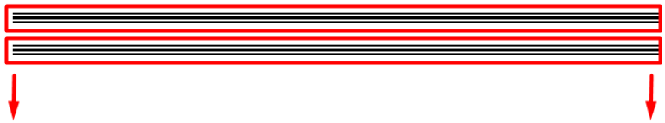

2

الينك ده فى كميه معلومات كويسه منها انك ممكن تعمل حاجه زى كده

<https://www.plus2net.com/html_tutorial/button-linking.php>

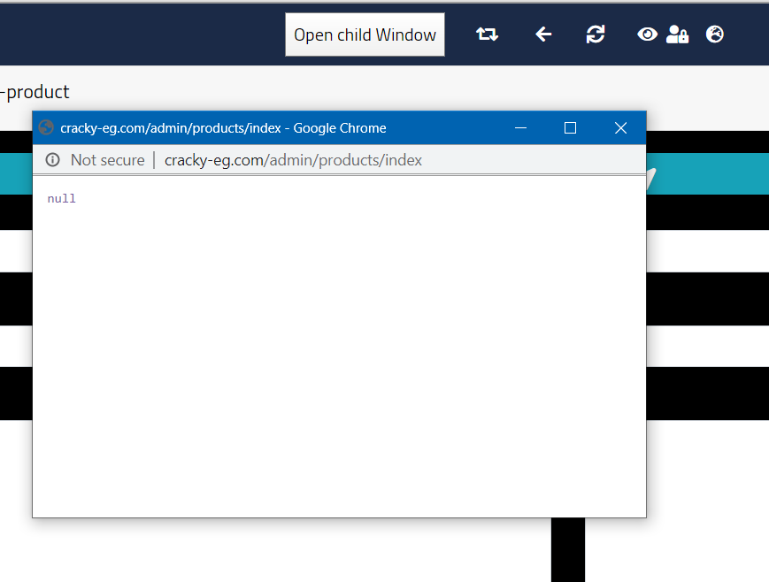

تعالى نشوف كده الافكار



تعالى بقا بى المره وبى الصدفه ازى تعمل btn اعجاب للموقع بتاعك

[https://developers.facebook.com/docs/plugins/like-button/#example](https://developers.facebook.com/docs/plugins/like-button/" \l "example)

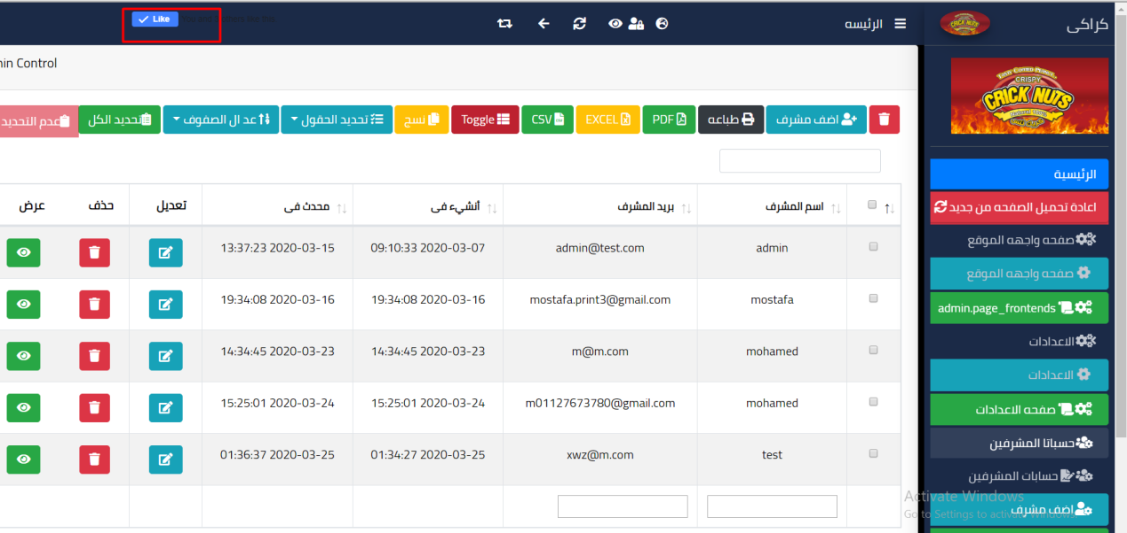

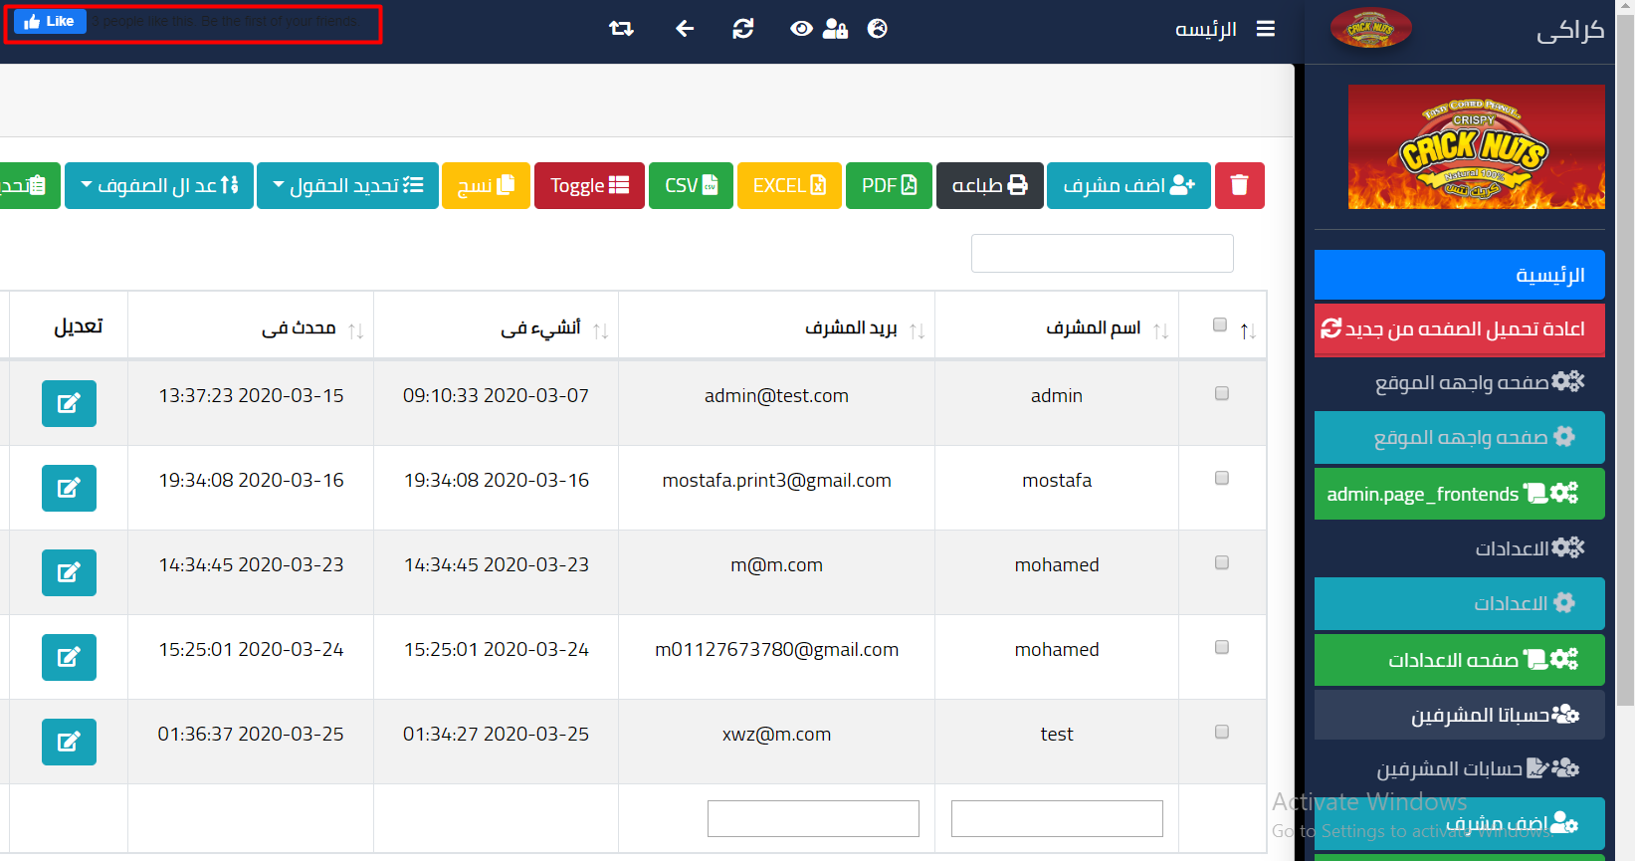

<html><head>

<title>Your Website Title</title>

<!-- You can use open graph tags to customize link previews.

Learn more: https://developers.facebook.com/docs/sharing/webmasters -->

<meta property="og:url" content="https://www.your-domain.com/your-page.html" />

<meta property="og:type" content="website" />

<meta property="og:title" content="Your Website Title" />

<meta property="og:description" content="Your description" />

<meta property="og:image" content="https://www.your-domain.com/path/image.jpg" /></head><body>

<!-- Load Facebook SDK for JavaScript -->

<div id="fb-root"></div>

<script async defer crossorigin="anonymous" src="https://connect.facebook.net/en_US/sdk.js#xfbml=1&version=v3.0"></script>

<!-- Your like button code -->

<div class="fb-like"

data-href="https://www.your-domain.com/your-page.html"

data-layout="standard"

data-action="like"

data-show-faces="true">

</div>

</body></html>

هيدهولك بى الشكل ده بس ده الكود جاهز على طول

<aside>  
  
 <!-- start btn like --------------------->  
 <!-- Load Facebook SDK for JavaScript -->  
 <div id="fb-root"></div>  
 <script>(function(d, s, id) {  
 var js, fjs = d.getElementsByTagName(s)[0];  
 if (d.getElementById(id)) return;  
 js = d.createElement(s); js.id = id;  
 js.src = "https://connect.facebook.net/en_US/sdk.js#xfbml=1&version=v3.0";  
 fjs.parentNode.insertBefore(js, fjs);  
 }(***document***, 'script', 'facebook-jssdk'));</script>  
  
 <!-- Your share button code -->  
 <div class="fb-share-button"  
 data-href="http://cracky-eg.com"  
 data-layout="button_count">  
 </div>  
 <!-- End btn like --------------------->  
  
</aside>

...........................................................................…

وده زار المشاركه كمان

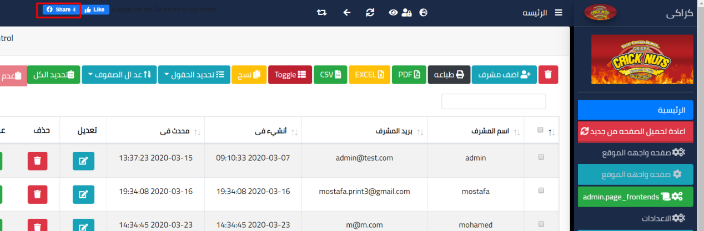

<https://developers.facebook.com/docs/plugins/share-button>

<html><head>

<title>Your Website Title</title>

<!-- You can use Open Graph tags to customize link previews.

Learn more: https://developers.facebook.com/docs/sharing/webmasters -->

<meta property="og:url" content="https://www.your-domain.com/your-page.html" />

<meta property="og:type" content="website" />

<meta property="og:title" content="Your Website Title" />

<meta property="og:description" content="Your description" />

<meta property="og:image" content="https://www.your-domain.com/path/image.jpg" /></head><body>

<!-- Load Facebook SDK for JavaScript -->

<div id="fb-root"></div>

<script>(function(d, s, id) {

var js, fjs = d.getElementsByTagName(s)[0];

if (d.getElementById(id)) return;

js = d.createElement(s); js.id = id;

js.src = "https://connect.facebook.net/en_US/sdk.js#xfbml=1&version=v3.0";

fjs.parentNode.insertBefore(js, fjs);

}(document, 'script', 'facebook-jssdk'));</script>

<!-- Your share button code -->

<div class="fb-share-button"

data-href="https://www.your-domain.com/your-page.html"

data-layout="button_count">

</div>

</body></html>

….………………………………………………………………………………………………………………

وده الزار حفظ

<https://developers.facebook.com/docs/plugins/save>

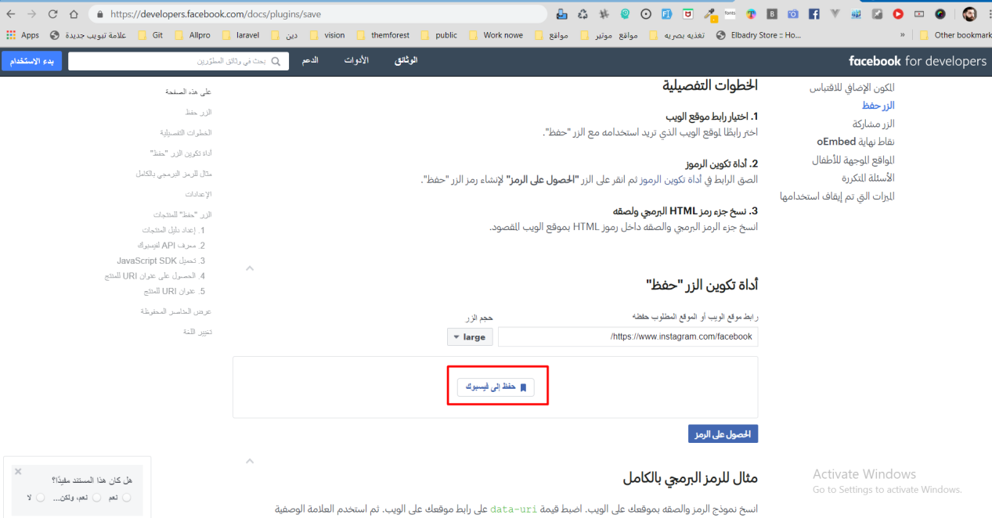

<!-------------------- start Save to face book --------------------------->

<div id="fb-root"></div>

<script async defer crossorigin="anonymous" src="https://connect.facebook.net/ar_AR/sdk.js#xfbml=1&version=v6.0"></script>

<div class="fb-save" data-uri="https://www.instagram.com/facebook/" data-size="large"></div>

<!-- Load Facebook SDK for JavaScript -->

<div id="fb-root"></div>

<script>(function(d, s, id) {

var js, fjs = d.getElementsByTagName(s)[0];

if (d.getElementById(id)) return;

js = d.createElement(s); js.id = id;

js.src = "https://connect.facebook.net/en_US/sdk.js#xfbml=1&version=v2.6";

fjs.parentNode.insertBefore(js, fjs);

}(document, 'script', 'facebook-jssdk'));</script>

<!-- Your save button code -->

<div class="fb-save"

data-uri="http://cracky-eg.com/">

</div>

<!-------------------- End Save to face book --------------------------->

….………………………………………………………………………عمل شير على جميع المواقع ………………………………..

ودده الينك وهتابع مع الموقع ده

[https://www.addthis.com/dashboard#get-the-code/pub/ra-5e7d2f2c69fb5751](https://www.addthis.com/dashboard" \l "get-the-code/pub/ra-5e7d2f2c69fb5751)

<!-- Go to www.addthis.com/dashboard to customize your tools -->

<script type="text/javascript" src="//s7.addthis.com/js/300/addthis_widget.js#pubid=ra-5e7d2f2c69fb5751"></script>

….……………………………………………………………………………………………………………

….……………………………………………………………………………………………….…………………………………………

عمل شير بطريقه تانيه

<https://sharethis.com/onboarding/?b=s>

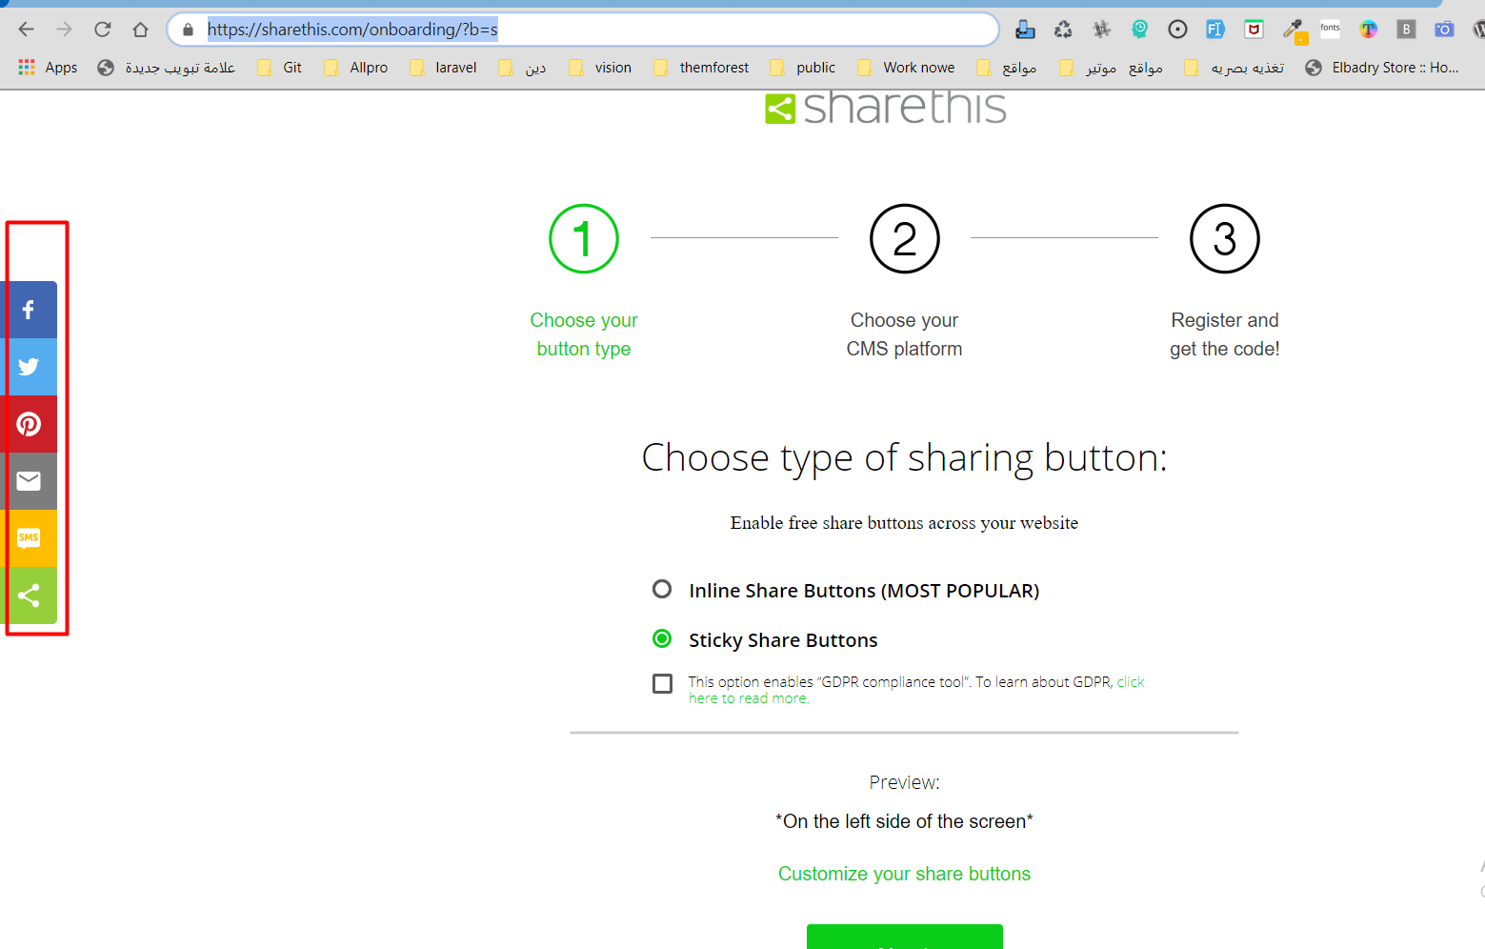

تانى خطوه هى بتختار يعملك الكود على شكل اى

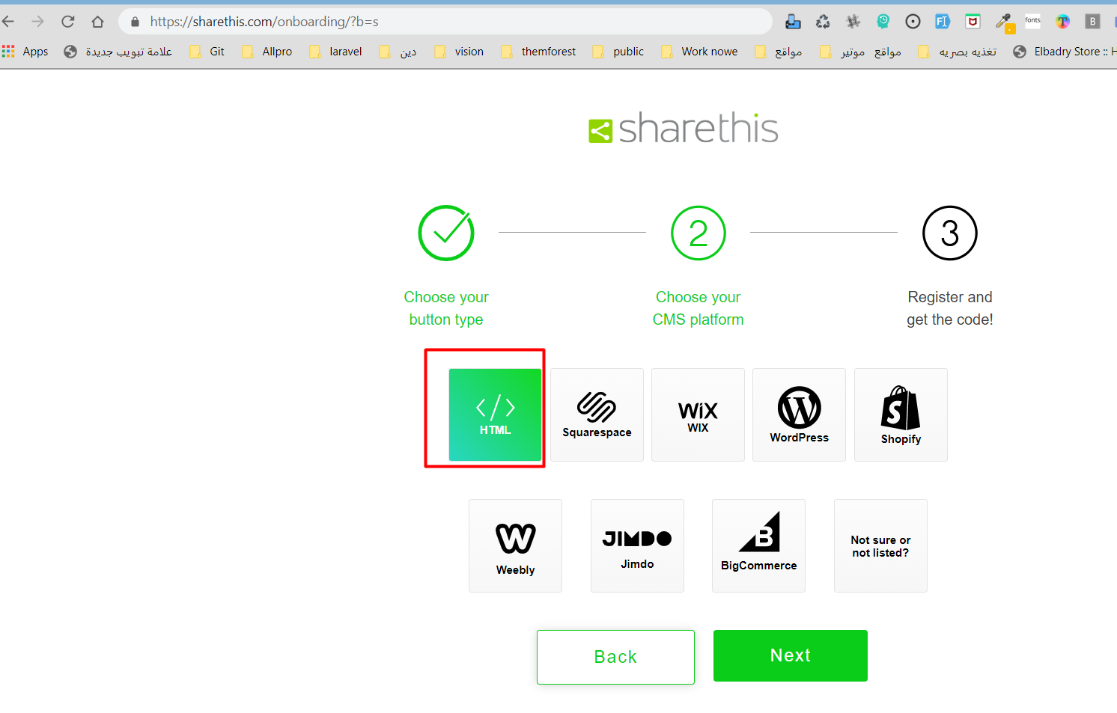

<script async src="https://platform-api.sharethis.com/js/sharethis.js#property=5e7d3a6c92f54300123e5998&product=sticky-share-buttons"></script>

….……………………………………………………………………………………………….…………………………………………

@@@@@@@@@@@@@@@@@@@@@@@@@@@@@@@@@@@@@

[https://www.addthis.com/register?next=/dashboard#tool-config](https://www.addthis.com/register?next=/dashboard" \l "tool-config)

,وده موقع تانى وطريقه تانيه كويسه جدااااااااااااااااااااااا

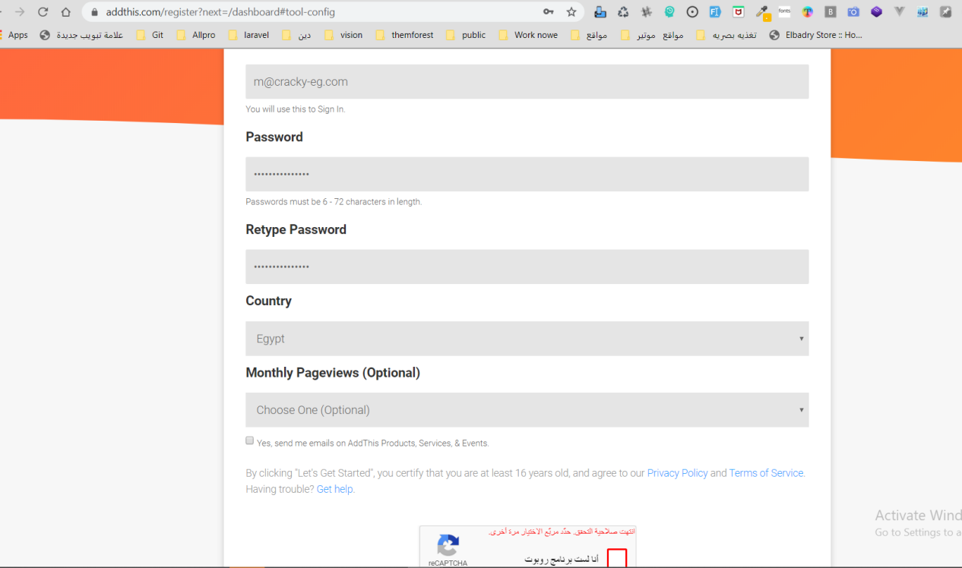

عايزين ابقى ابص على الينكات دى

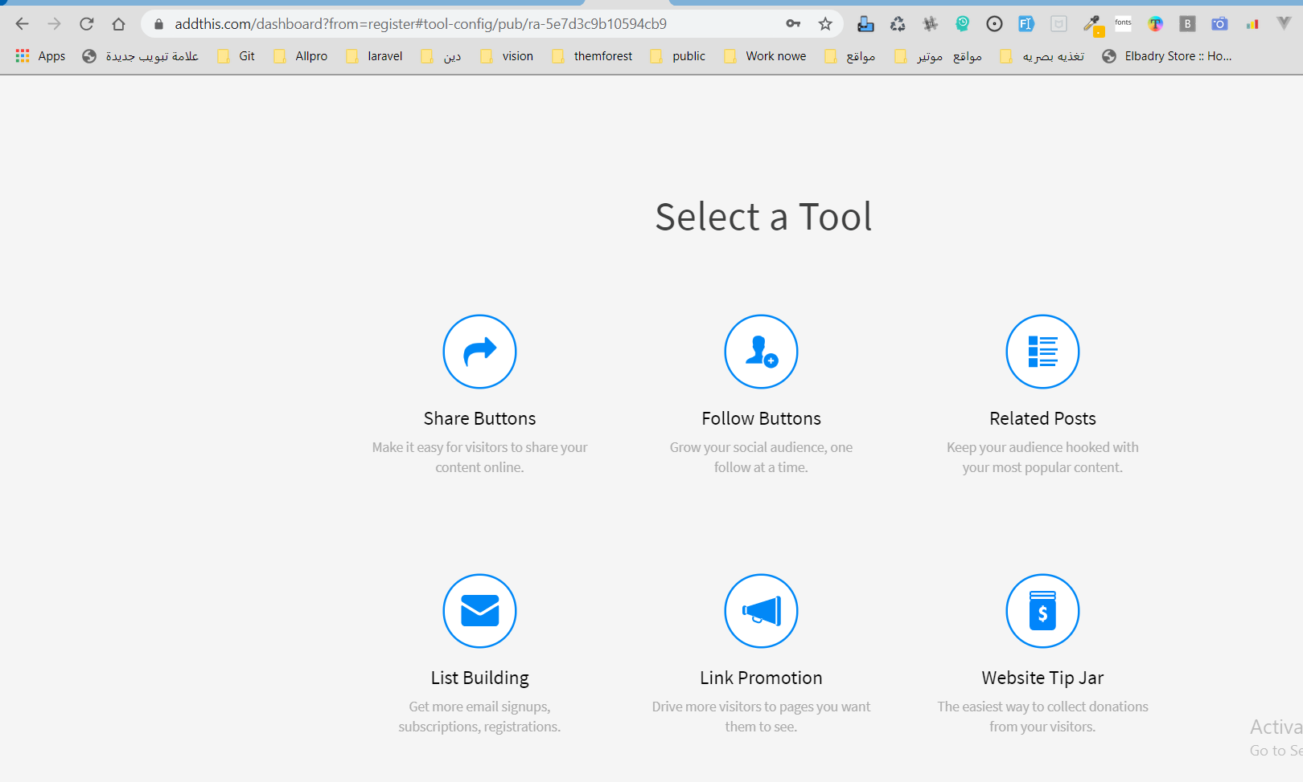

انا اختارت ال شير بس دلوقت

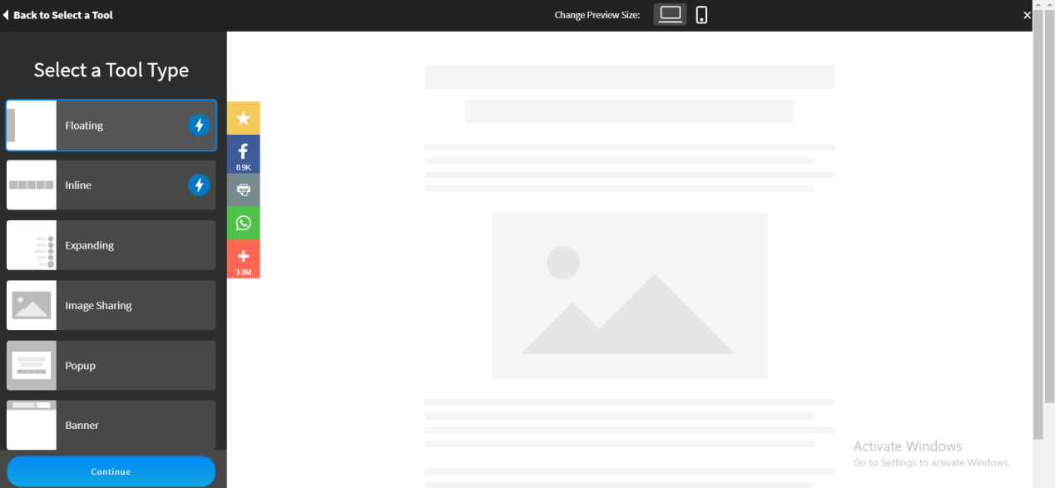

وبعد كده بتروح تنسق الححاجات الى انت عايزها تظهر معاك

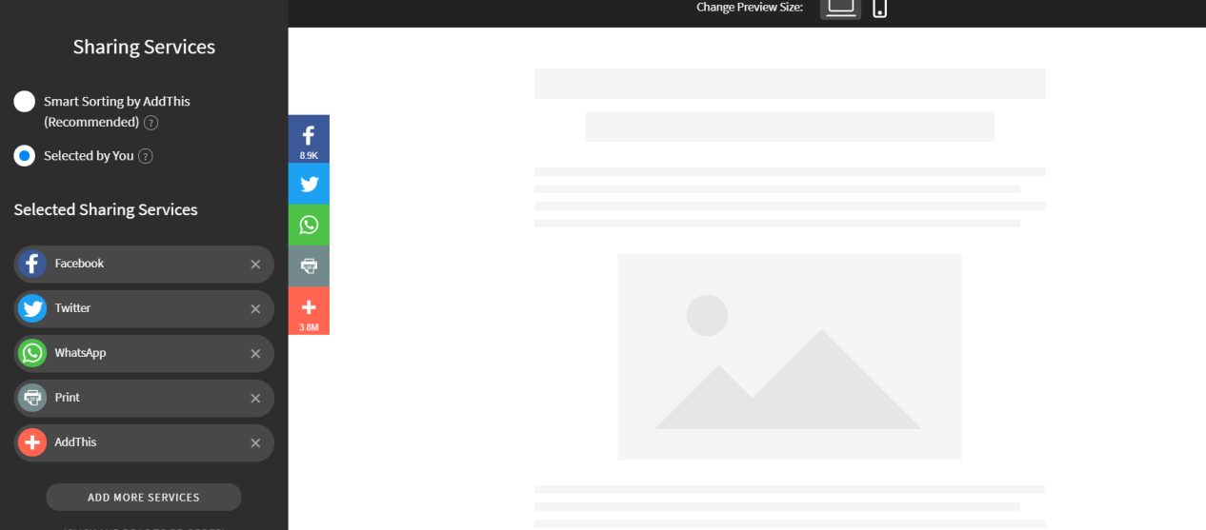

وفيه كذا شكل

بعد كده بيطلعلك الكود بتاعك

<script type="text/javascript" src="//s7.addthis.com/js/300/addthis_widget.js#pubid=ra-5e7d3c9b10594cb9"></script>

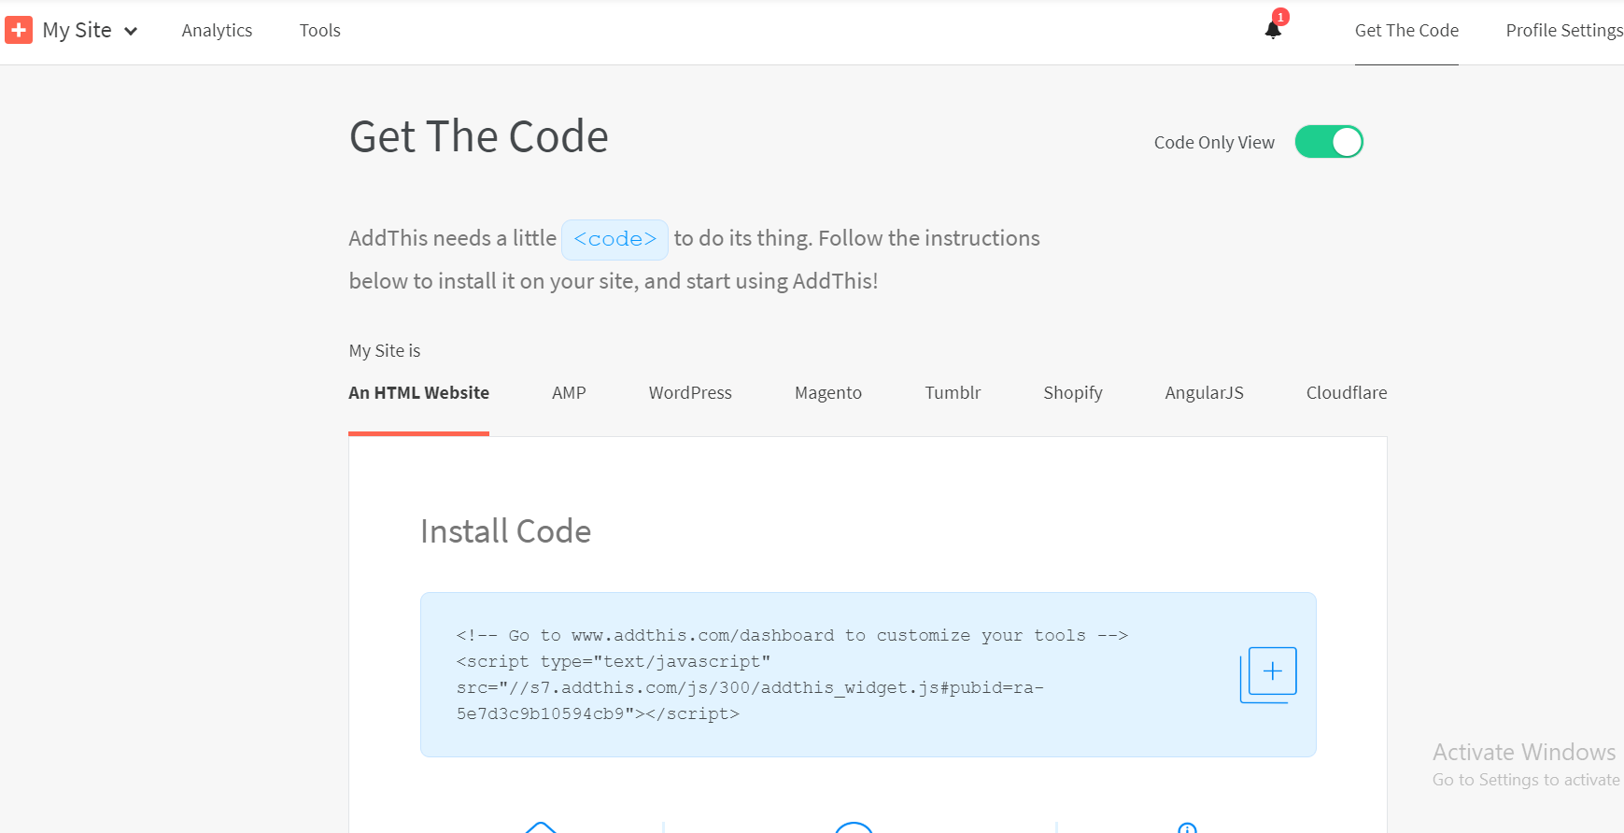

@@@@@@@@@@@@@@@@@@@@@@@@@@@@@@@@@@@@

والموقع ده

<https://platform.sharethis.com/sticky-share-buttons>

.

<script type='text/javascript' src='https://platform-api.sharethis.com/js/sharethis.js#property=5e7d3a6c92f54300123e5998&product=sticky-share-buttons&cms=website' async='async'></script>

